Chapter 4, Solution 41

To find R_{Th}, consider the circuit below

14
a

6 5

b

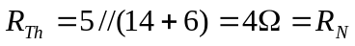
Applying source transformation to the 1-A current source, we obtain the circuit below.

6 - 14V + 14 V_{Th}
a

+

6V 3A 5

-
b

At node a,
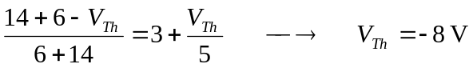

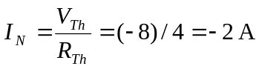
Thus,

